In all the form date field is responsive in computer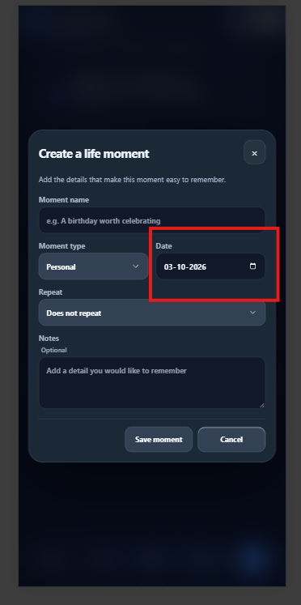

When I open this in mobile, like the format is broken for all date fields.
